
STUDENT CASE STUDY EXECUTION REPORT
Department | FED
Subject | DSA – 2
Academic Year | I-III Semester (2025 – 26)
Faculty Name | Ms. Mamatha
Student Name | Uppalapati Venkata Naga Varshitha
Roll Number | 2520030206
Branch | CSE
Course Outcome | CO 1 – Trees & Balanced Search Structures

Case Study Title: Shipment Record Management using AVL Trees in SmartLogix

Problem Statement:
SmartLogix is a logistics and supply chain optimization platform that handles large numbers of shipment records daily. Efficient management of shipment information is important to ensure fast searching, insertion, deletion, and report generation.
In this case study, AVL Trees are used to maintain balanced shipment records indexed by ShipmentID. AVL Trees improve searching performance by automatically balancing the tree after insertion and deletion operations.

Objectives:
- Implement AVL Tree for shipment management
- Insert shipment records efficiently
- Search shipment records using ShipmentID
- Delete shipment records
- Generate sorted shipment reports using tree traversal
- Maintain balanced data for fast operations

Algorithm Used:
AVL Tree is a self-balancing Binary Search Tree where the height difference between left and right subtrees is at most 1.
Operations Performed: Insertion, Deletion, Searching, Inorder Traversal, Rotations for balancing.
Code Implementation:
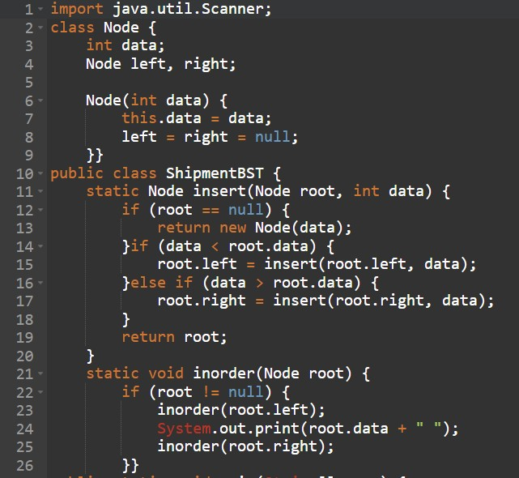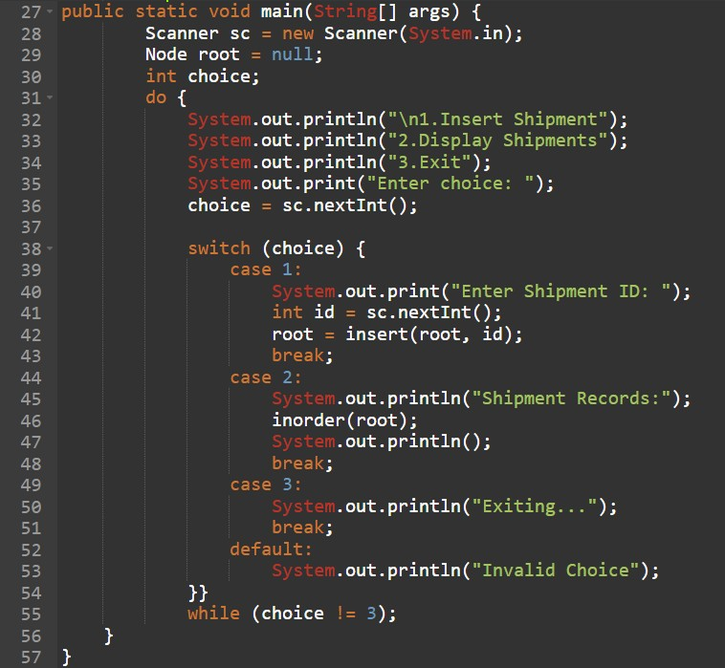
Sample Output:
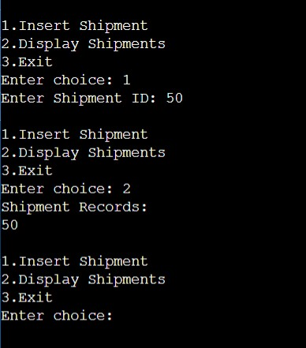
Result:
The AVL Tree successfully managed shipment records in a balanced manner. Shipment insertion, searching, and traversal operations were performed efficiently. AVL balancing improved search performance and ensured optimized logistics data management.
Time Complexity:
- Insertion: O (log n)
- Searching: O (log n)
- Deletion: O (log n)

Advantages:
- Fast searching operation
- Balanced data structure
- Efficient shipment indexing
- Sorted report generation
- Suitable for large logistics databases

Applications:
- Shipment tracking systems
- Warehouse management
- Inventory databases
- Logistics analytics systems

Conclusion:
This case study demonstrated how AVL Trees can be used in SmartLogix for efficient shipment record management. Balanced search structures improve overall logistics performance by reducing search time and maintaining organized shipment data.

Github Link: https://github.com/srinivasvarshi7-beep/DSA-2-Casestudy.git

Student Signature: | Faculty Signature:

